%Exercise 1

%Part (a)

function LAB04ex1

formatlong

t0=0; w

tf=40;

Y0=[-1;0];

[t,Y]=ode45(@f,[t0,tf],Y0);

y=Y(:,1);

v=Y(:,2);

figure(1);

plot(t,y,'b-+',t,v,'ro-')

legend('y(t)','v(t)=y''(t)')

gridon;

ylim([-1.5,1.5]);

[t,Y(:,1)]

figure(2);

plot(y,v)

axissquare;

xlabel('y'); ylabel('v=y''(t)');

gridon

ylim([-1.5,1.5]); xlim([-1,1]);

end

functiondYdt=f(t,Y)

y=Y(1);

v=Y(2);

dYdt=[v;cos(t)-4*v-3*y];

end

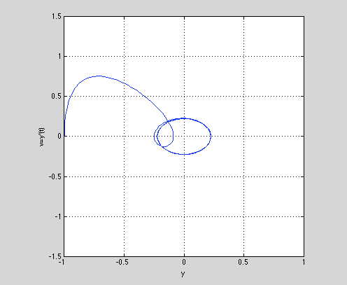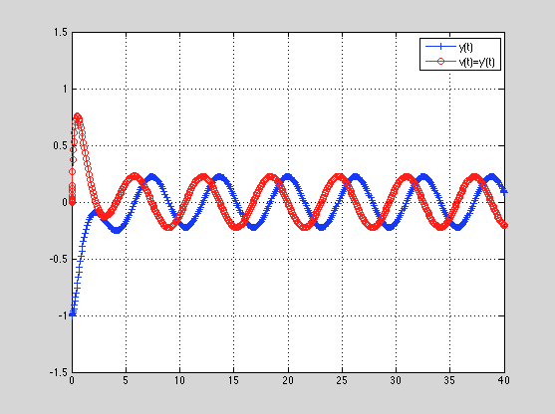

%Part b

The approximate t values for which y has a local max or min

|  |  |  |
| --- | --- | --- |
| t value | Y(t) | Local min or max |
| 2.134 | -.0903 | max |
| 4.128 | -.2503 | min |
| 7.646 | .2155 | max |
| 10.552 | -.2233 | min |
| 13.663 | .2236 | max |
| 16.785 | -.2234 | min |
| 19.932 | .2235 | max |
| 23.073 | -.2235 | min |
| 26.215 | .2235 | max |
| 29.357 | -.2235 | min |
| 32.498 | .2235 | max |
| 35.639 | -.2235 | min |
| 38.781 | .2235 | max |

%Part c

The long term behavior of y(t) appears to be the same sine wave graph with with local max value of .2235 and local min value of -.2235.

%Part d

function LAB04ex1A

t0=0;

tf=40;

Y0=[1.5;5];

[t,Y]=ode45(@f,[t0,tf],Y0);

y=Y(:,1);

v=Y(:,2);

figure(1);

plot(t,y,'b-+',t,v,'ro-')

legend('y(t)','v(t)=y''(t)')

gridon;

ylim([-1.5,1.5]);

[t,Y(:,1)]

figure(2);

plot(y,v)

axissquare;

xlabel('y'); ylabel('v');

gridon

ylim([-1.5,1.5]); xlim([-1,1]);

end

functiondYdt=f(t,Y)

y=Y(1);

v=Y(2);

dYdt=[v; cos(t)-4*v-3*y];

end

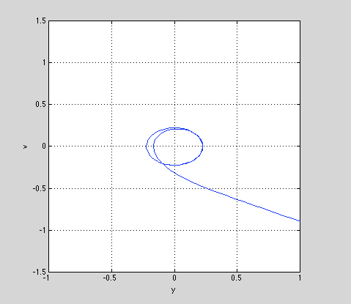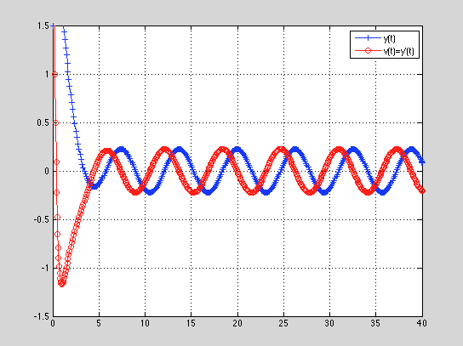

The modified graph of y(t) appears to have the same long term behavior as the graph of y(t). This is because the only difference between the two graphs is the initial conditions. The functions were exactly the same.

%Exercise 2

%Part a

function LAB04ex2B

t0=0;

tf=40;

Y0=[-1;0];

[t,Y]=ode45(@f,[t0,tf],Y0);

y=Y(:,1);

v=Y(:,2);

[te,Ye]=euler(@f,[0,40],Y0,400);

figure(1);

plot(t,y,'b',t,v,'r')

legend('y(t)','v(t)=y''(t)')

gridon;

figure(2);

plot(y,v,'k')

axissquare;

xlabel('y'); ylabel('v');

gridon

figure(3); %plot of Euler approximation

plot(te,Ye,'r',t,y,'k')

legend('Euler''s Approximation')

end

functiondYdt=f(t,Y)

y=Y(1);

v=Y(2);

dYdt=[v;cos(t)-4*v*y^2-3*y];

end

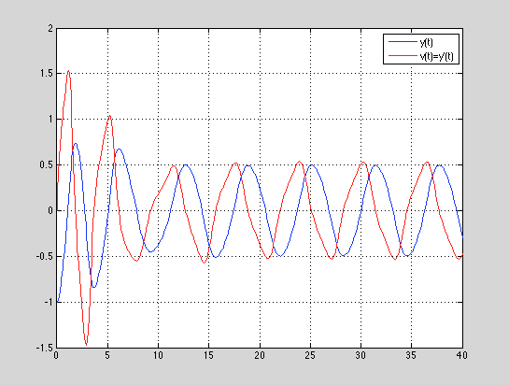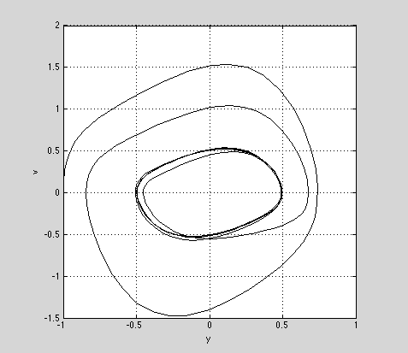

%Part b

When comparing the graphs from Exercise 2 to those from Exercise 1, there is not much correlation between the short-term behaviors.

%Part c

However, when observing the long-term behavior, the t values for the local extrema are the same for both graphs. Also the maximum and minimum values for both graphs have the same magnitude just opposite sign in the long term.

%Part d

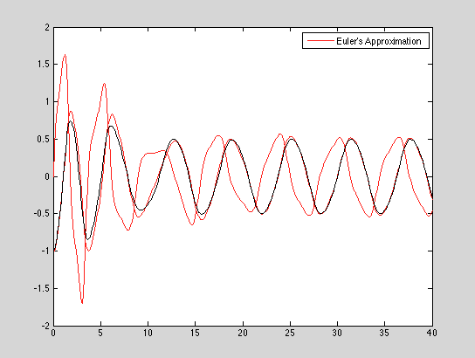

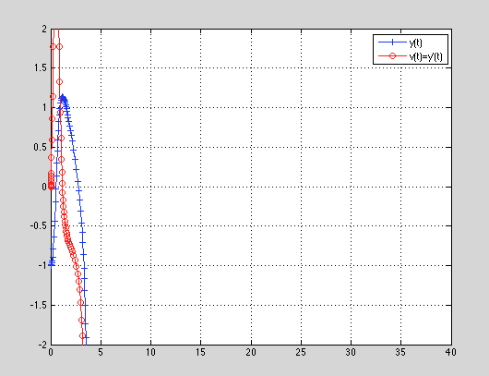%Exercise 3

function LAB04ex3C

t0=0;

tf=40;

Y0=[-1;0];

[t,Y]=ode45(@f,[t0,tf],Y0);

y=Y(:,1);

v=Y(:,2);

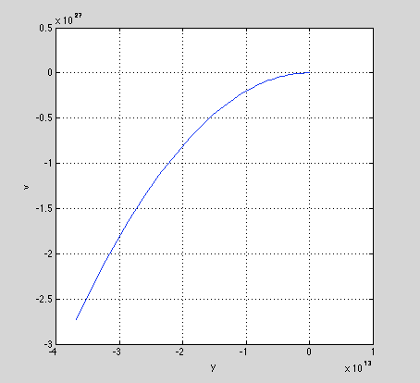

figure(1);

plot(t,y,'b-+',t,v,'ro-')

legend('y(t)','v(t)=y''(t)')

gridon;

ylim([-2,2]);xlim([0,40]);

figure(2);

plot(y,v)

axissquare;

xlabel('y'); ylabel('v');

gridon

end

functiondYdt=f(t,Y)

y=Y(1);

v=Y(2);

dYdt=[v;cos(t)-4*v*y-3*y];

end

The behavior of these solutions in Exercise 3 are significantly different than the solutions in Exercise 2. The graphs do not resemble each other.

MATLAB does give a warning message which states:

Warning: Failure at t=3.774765e+00. Unable

tomeet integration tolerances without reducing

the step size below the smallest value allowed

(7.105427e-15) at time t.

> In ode45 at 309

This warning means that at that point, the problem is “stiff” because it is varying slowly while all the other solution around it are varying rapidly.

%Exercise 4

%Part a

function LAB04ex4d

t0=0;

tf=40;

Y0=[-1;0;4]

[t,Y]=ode45(@f,[t0,tf],Y0);

y=Y(:,1);

v=Y(:,2);

w=Y(:,3);

figure(1);

plot(t,y,'b-+',t,v,'ro-',t,w,'k')

legend('y(t)','v(t)=y''(t)','w(t)=y''''(t)')

gridon;

ylim([-1.5,1.5]);

figure(2);

plot3(y,v,w,'k.-');

axissquare;

xlabel('y'); ylabel('v=y'''); zlabel('w=y''''')

gridon

view([-40,60])

end

functiondYdt=f(t,Y)

y=Y(1);

v=Y(2);

w=Y(3);

dYdt=[v;w;-sin(t)-4*y^2*w-8*y*v^2-3*v];

end

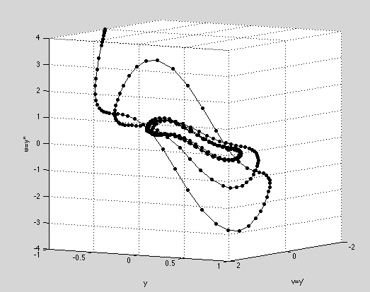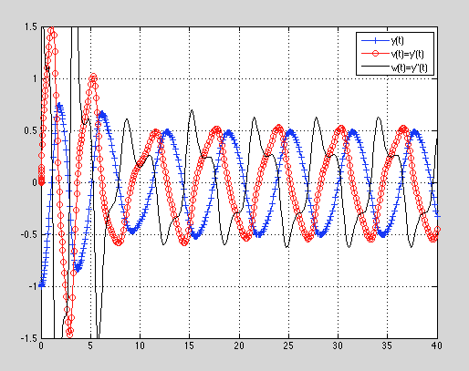%Part b

Upon inspection, when comparing the wave graph from Part (a) with the wave graph from Exercise 2 Part(a), it can be seen that two of the time series graphs are exactly the same. In this case, the red graphs from each and the blue graphs from each correspond with each other respectively.

%Part c

The derivative of the ODE is $\frac{d^{3}y}{{dt}^{3}}+ \frac{4y^{2}d^{2}y}{dt^{2}}+8y(\frac{dy}{dt})^{2}+3y\frac{dy}{dt}$

%Part d

The derivative of the first ODE is dependent on the solution of the second ODE.